SOFTWARE ENGINEERING - CASE STUDY ANALYSIS

CASE STUDY ANALYSIS
AI-Based Smart Cold Chain Logistics
Monitoring and Optimization Platform
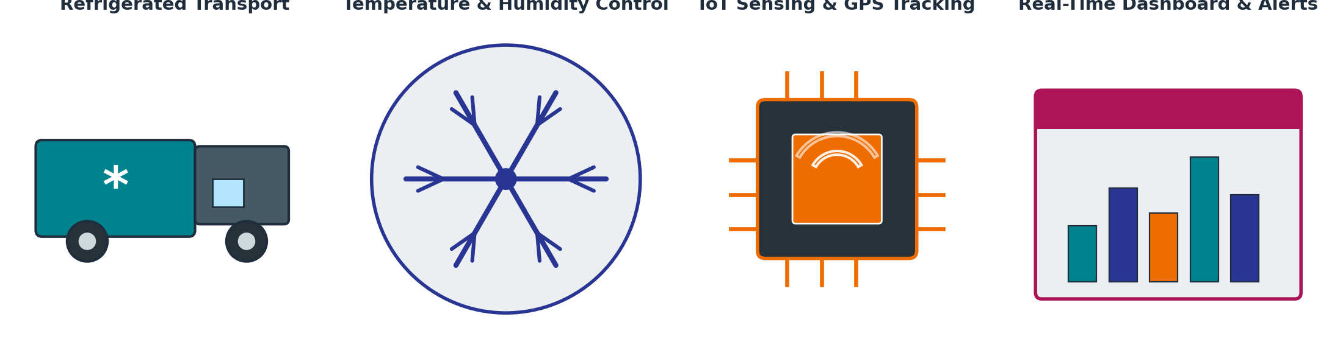
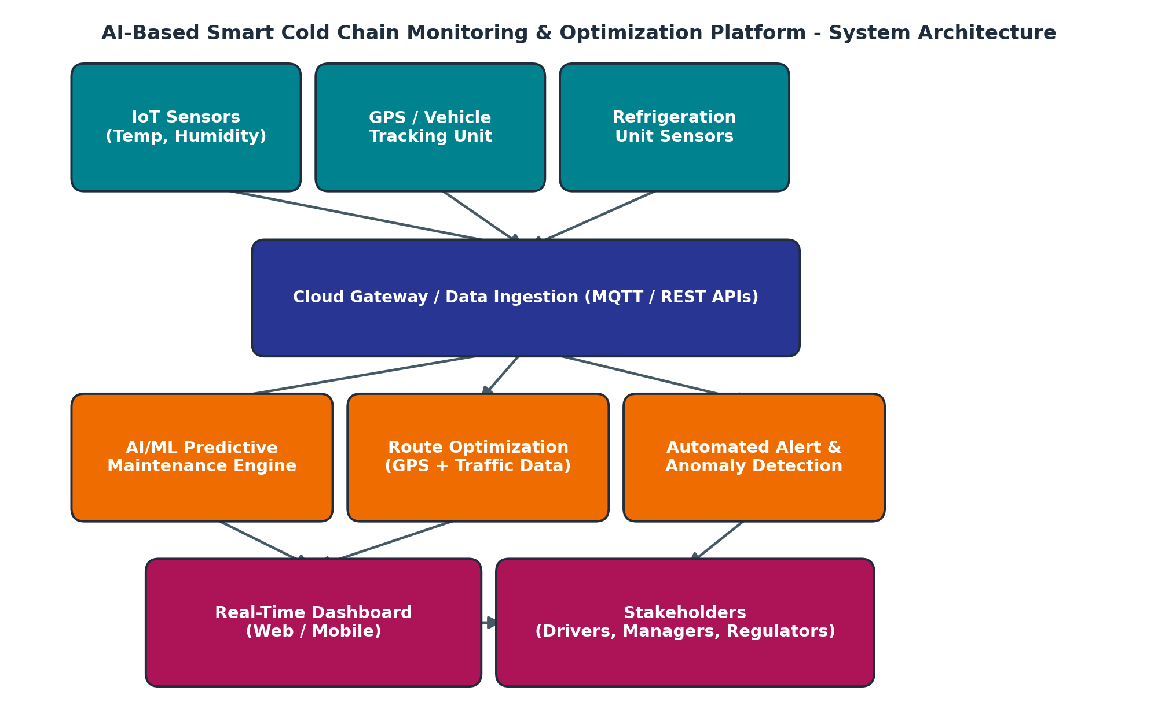
CO1 Assessment 1
Manisha M (192424130)
BTech – AI & DS
CSA1017: Software Engineering

1. Introduction and Problem Understanding

1.1 Problem Statement (in own words)
Cold chain logistics is the process of transporting temperature-sensitive goods such as vaccines, pharmaceuticals, dairy products, seafood, and fresh produce while keeping them within a strict temperature and humidity range from origin to destination. Even a short break in this controlled environment, caused by a faulty refrigeration unit, a delayed shipment, or a missed inspection, can spoil an entire consignment. Today, most cold chain operators rely on manual temperature logging, periodic spot-checks, and phone-based escalation when something goes wrong. This approach is reactive rather than preventive: by the time spoilage or a compliance breach is detected, the financial and safety damage has already occurred. The problem this project addresses is the absence of continuous, intelligent, real-time monitoring across the cold chain. The proposed solution is a software platform that uses IoT sensors, GPS tracking, cloud computing, and AI-based predictive analytics to continuously monitor temperature, humidity, and vehicle location, to forecast equipment failures before they happen, to recommend optimized delivery routes, and to raise automated alerts through a live dashboard, so that quality loss is prevented instead of discovered after the fact.
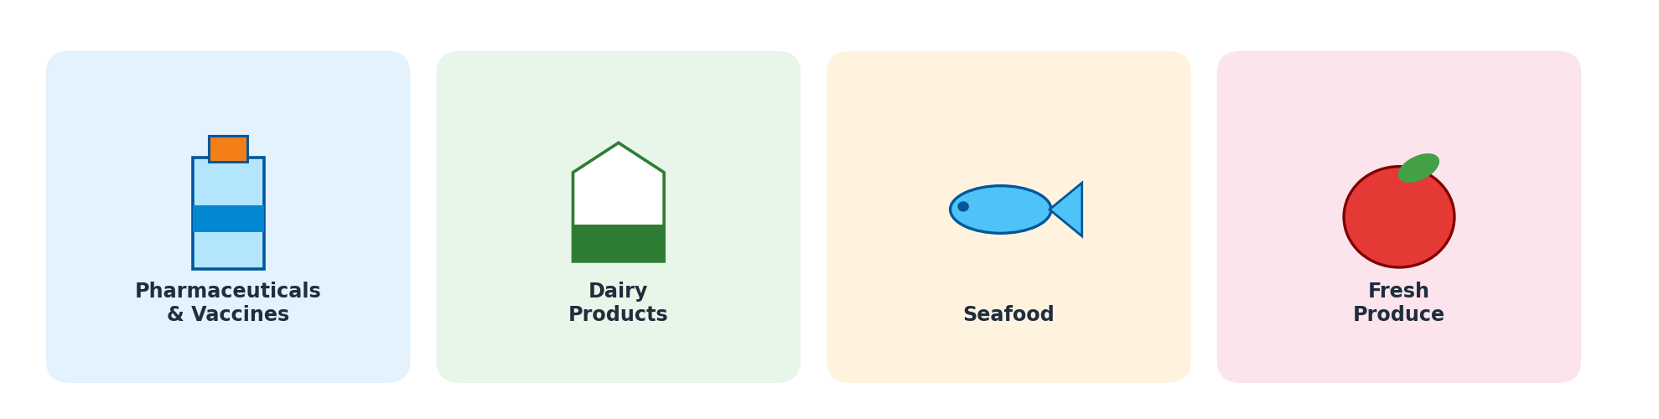
Figure 1: Categories of temperature-sensitive goods carried through the cold chain.

1.2 Objectives of the Proposed System
- Continuously monitor temperature and humidity of the cargo throughout transit.
- Track shipment and vehicle location in real time using GPS.
- Predict refrigeration equipment failures before they cause spoilage.
- Optimize transportation routes to reduce transit time and fuel cost.
- Generate automated quality and compliance alerts for stakeholders.
- Analyze historical logistics performance to identify recurring issues.
- Reduce product spoilage and the associated financial losses.
- Improve end-to-end supply chain visibility for all stakeholders.

1.3 Scope of the Problem
The scope of this project covers the monitoring and management layer of cold chain transportation, from the moment goods are loaded into a refrigerated vehicle to the moment they are delivered. It includes IoT sensor data acquisition, cloud-based data processing, AI-driven prediction and optimization, and a dashboard/alert layer for stakeholders. It does not extend to the physical manufacturing of refrigeration hardware, nor to the broader enterprise resource planning (ERP) or inventory-management functions of the organizations involved, although the platform is designed to integrate with such systems through APIs. The system is intended for road-based cold chain transport (trucks and vans) carrying pharmaceuticals, dairy, seafood, and fresh produce, and is scalable to multi-vehicle fleets.

2. Stakeholder Analysis

2.1 Key Stakeholders, Roles and Responsibilities
Stakeholder | Role | Responsibility
Logistics / Fleet Operator | Owns and manages the transport fleet | Ensures vehicles are maintained, deploys drivers, monitors dashboard
Driver | Operates the refrigerated vehicle | Follows optimized routes, responds to on-board alerts
Cold Storage Warehouse Staff | Manages storage before/after transit | Ensures correct handover temperature, records inspections
Manufacturer / Shipper (Pharma, Dairy, Seafood) | Owner of the goods being transported | Sets quality requirements, monitors shipment status
Regulatory / Compliance Body | Enforces safety and quality standards | Audits temperature logs, certifies compliance
End Customer / Retailer | Receiver of the goods | Verifies product quality on delivery
IT / Platform Maintenance Team | Maintains the software platform | Ensures uptime, sensor calibration, model retraining

2.2 Major Challenges Faced by Stakeholders
- Fleet operators lack real-time visibility into every vehicle's internal conditions simultaneously.
- Drivers have no early warning of refrigeration unit degradation until it visibly fails.
- Manufacturers face liability and reputational risk when spoiled goods reach customers.
- Regulators struggle to audit paper-based or fragmented digital temperature logs.
- Customers receive degraded products with no visibility into what went wrong in transit.
- IT teams face pressure to keep sensor networks and connectivity reliable across wide geographic areas.

3. Analysis of the Current Approach

3.1 Description of the Existing Process
In the current process, refrigerated vehicles are fitted with basic temperature gauges or simple standalone data loggers that record readings at fixed intervals. Drivers or warehouse staff manually note temperature readings on paper or in a basic spreadsheet at loading, at intermediate checkpoints, and at delivery. If a refrigeration unit begins to fail, there is typically no automated signal; the problem is only discovered when a physical inspection is performed or when the driver notices a change in the vehicle cabin. Route planning is largely static and based on the driver's experience or a generic mapping application, without factoring in real-time traffic, weather, or the urgency of the specific cargo. When an issue does occur, it is reported by phone call to a dispatcher, who then manually coordinates a response.

3.2 Strengths and Limitations of the Current System
Aspect | Strength | Limitation
Monitoring | Simple, low equipment cost | No real-time visibility; only periodic snapshots
Alerting | Human judgement can catch obvious problems | Detection is delayed until damage is visible
Route Planning | Familiar, uses driver experience | Static; ignores real-time traffic and weather
Record Keeping | Simple paper/spreadsheet logs | Error-prone, hard to audit, easily lost
Escalation | Direct human communication | Slow, inconsistent, not scalable across a large fleet

3.3 Gaps That Need to Be Addressed
- No continuous, automated sensing of temperature and humidity in transit.
- No predictive capability to flag refrigeration failures before they occur.
- No dynamic route optimization based on live traffic and cargo urgency.
- No unified, real-time dashboard accessible to all relevant stakeholders.
- No structured, tamper-proof digital record for compliance audits.
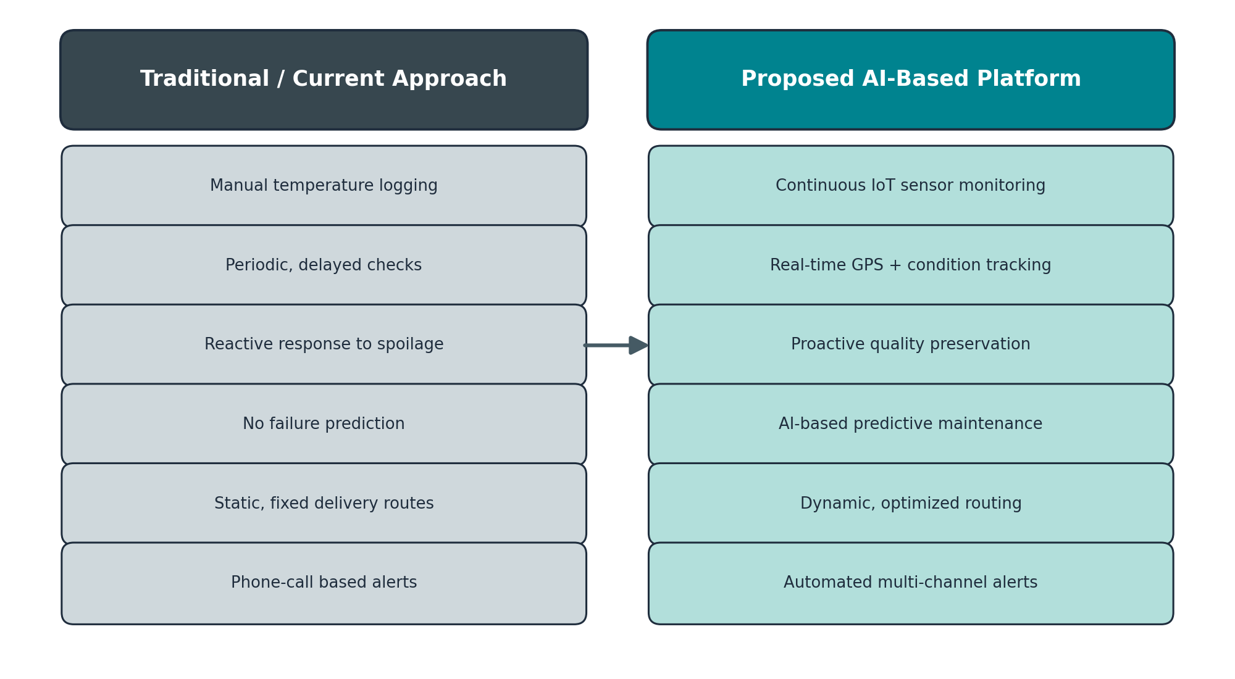
Figure 2: Traditional cold chain monitoring compared with the proposed AI-based platform.

4. Proposed Software Solution

4.1 System Overview
The proposed solution is a layered software platform. IoT sensors mounted inside the refrigerated compartment continuously capture temperature and humidity, while a GPS unit tracks vehicle location; refrigeration-unit sensors capture compressor performance data. This data is transmitted through a cloud gateway using lightweight IoT protocols (such as MQTT) to a cloud backend. There, an AI/ML predictive-maintenance engine analyzes sensor trends to forecast refrigeration failures, a route-optimization module combines GPS and traffic data to recommend efficient delivery paths, and an anomaly-detection module raises automated alerts when readings deviate from safe thresholds. Processed information is finally surfaced through a real-time web and mobile dashboard used by fleet operators, drivers, regulators, and customers.

Figure 3: Proposed system architecture for the AI-based cold chain platform.

4.2 Major Functional Modules
Module | Function
Sensor Data Acquisition Module | Collects temperature, humidity, and equipment data from IoT devices
GPS Tracking Module | Provides real-time vehicle location and movement data
Cloud Data Ingestion & Storage | Receives, validates, and stores incoming sensor data at scale
Predictive Maintenance Engine | Uses ML models to forecast refrigeration equipment failure
Route Optimization Engine | Recommends optimal delivery routes using live traffic/location data
Alert & Notification Module | Detects anomalies and pushes alerts to relevant stakeholders
Dashboard & Reporting Module | Displays live status, historical trends, and compliance reports
User & Access Management Module | Manages role-based access for drivers, operators, and regulators

4.3 Functional Requirements
- The system shall record temperature and humidity readings at fixed short intervals.
- The system shall track and update vehicle GPS location in real time.
- The system shall predict the likelihood of refrigeration failure using historical and live sensor data.
- The system shall generate an alert within a defined time when readings breach safe thresholds.
- The system shall recommend an optimized delivery route based on current traffic and cargo priority.
- The system shall allow authorized stakeholders to view live and historical shipment data through a dashboard.

4.4 Non-Functional Requirements
- Reliability: the platform must maintain continuous monitoring with minimal downtime.
- Scalability: the platform must support an expanding fleet and sensor network without redesign.
- Usability: the dashboard must be simple enough for drivers and warehouse staff with limited technical training.
- Security: sensor data and stakeholder access must be protected against tampering and unauthorized access.
- Performance: alerts must reach stakeholders within seconds of an anomaly being detected.
- Maintainability: individual modules must be independently upgradable, e.g., retraining the ML model.

4.5 Application of Software Engineering Principles
Principle | How It Is Applied
Modularity | The system is divided into independent modules (sensing, cloud ingestion, ML engine, routing, alerts, dashboard) that can be developed and updated separately
Scalability | Cloud-based, horizontally scalable architecture supports adding vehicles, sensors, and users without redesign
Maintainability | Clear module boundaries and APIs allow the predictive model or routing logic to be improved independently
Reliability | Redundant data transmission and offline buffering ensure no sensor data is lost during connectivity gaps
Usability | Role-based, simplified dashboards are tailored to each stakeholder's needs (driver view vs regulator view)
Security | Encrypted data transmission, authentication, and role-based access control protect sensitive shipment data

5. Justification of the Chosen Methodology / Framework

5.1 Selected SDLC Model: Agile (Scrum Framework)
The Agile methodology, implemented through the Scrum framework, is selected for developing this platform. Development proceeds in fixed-length sprints, each producing a working increment of the system, such as a functioning sensor-ingestion pipeline in one sprint and a working predictive-maintenance model in the next.
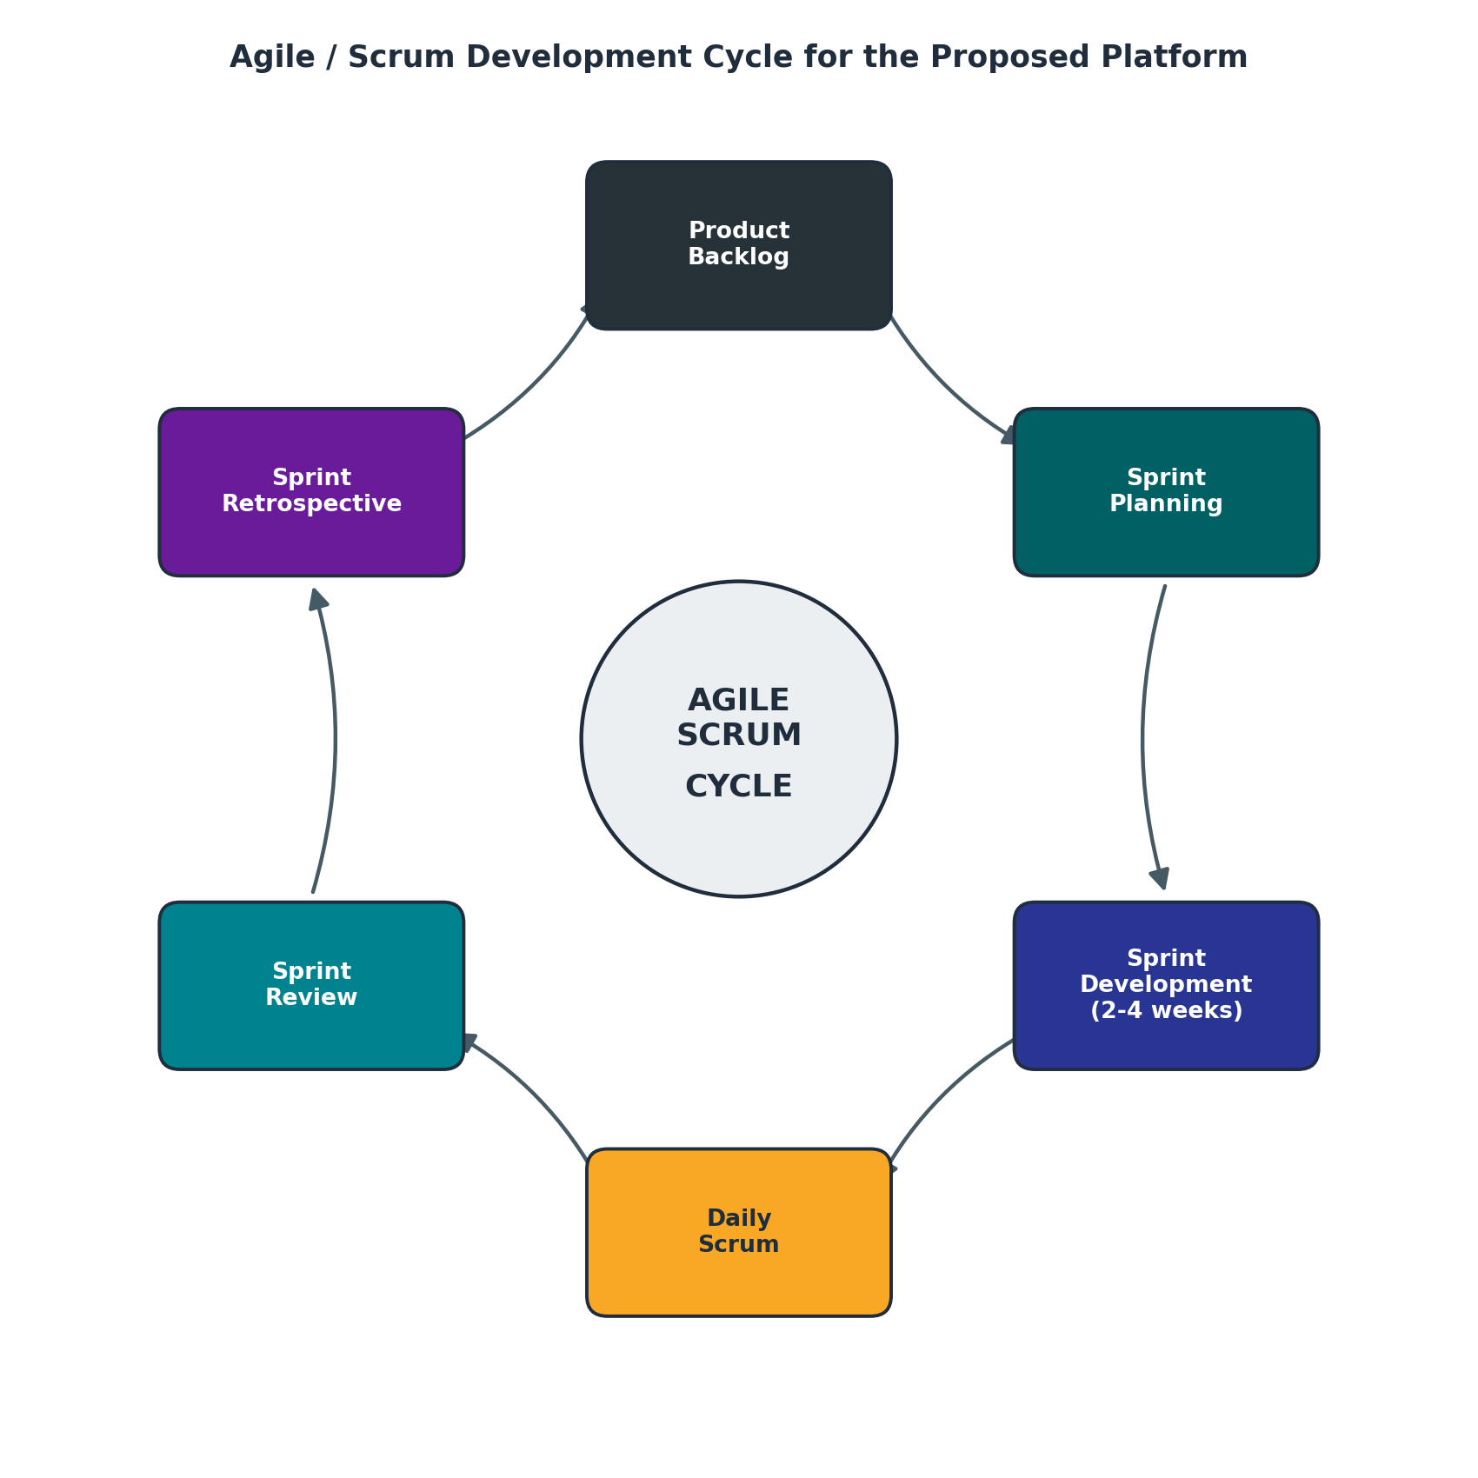
Figure 4: Agile / Scrum development cycle applied to the proposed platform.

5.2 Justification for Choosing Agile/Scrum
- The system integrates several evolving technologies (IoT, ML, routing algorithms), which benefits from iterative refinement rather than a single fixed design upfront.
- Requirements from multiple stakeholders (drivers, regulators, manufacturers) are likely to be clarified and adjusted as the project progresses, which Agile accommodates naturally.
- Sprint reviews with stakeholders ensure the dashboard and alerting logic genuinely match real operational needs before the full system is finalized.
- Machine learning components typically require retraining and tuning cycles, which map well onto repeated sprints rather than a one-time development phase.
- Agile reduces the risk of late discovery of major design flaws, since each sprint delivers a testable increment.

5.3 How Agile Supports Development and Maintenance
Because each sprint produces a working, testable module, defects and misaligned requirements are caught early rather than at the end of a long development cycle. Once deployed, the same sprint cycle supports ongoing maintenance: sensor firmware updates, ML model retraining as spoilage patterns evolve, and dashboard refinements based on stakeholder feedback can each be handled as future sprints without disrupting the rest of the system. This keeps the platform continuously improvable over its operational lifetime, which is essential for a system that depends on a predictive model whose accuracy must be maintained over time.

6. Expected Outcomes and Limitations

6.1 Expected Benefits
- Reduced product spoilage through continuous, predictive monitoring.
- Improved cold chain reliability due to early detection of equipment issues.
- Better logistics efficiency through optimized delivery routes.
- Enhanced product quality reaching end customers.
- Lower operational costs from reduced spoilage and fuel-efficient routing.
- Increased customer satisfaction and trust in product quality.
- Real-time shipment monitoring accessible to all stakeholders.
- Improved regulatory compliance through automated, tamper-resistant digital records.

6.2 How the Solution Addresses the Identified Challenges
The platform directly resolves the visibility gap identified in the current-system analysis by replacing periodic manual checks with continuous sensor monitoring, replaces reactive response with predictive maintenance alerts, and replaces static routing with data-driven optimization. This closes the gap between when a problem begins and when a stakeholder becomes aware of it, which was the central weakness of the traditional approach.

6.3 Potential Risks, Implementation Challenges and Limitations
- Initial hardware cost of fitting IoT sensors and GPS units across an entire fleet can be significant.
- Connectivity gaps in remote or rural transit routes may cause temporary data loss.
- Predictive model accuracy depends on the availability of sufficient historical failure data.
- Data privacy and security must be carefully managed, since shipment and location data can be sensitive.
- Driver and staff training is required to ensure proper use of the dashboard and alert system.

6.4 Possible Future Enhancements
- Integration with blockchain for tamper-proof, end-to-end compliance records.
- Expansion to multi-modal transport, including rail and air cold chain segments.
- Use of edge computing on vehicles to reduce dependency on constant connectivity.
- Integration with customer-facing apps for live shipment quality visibility.

7. Conclusion
This case study demonstrates that an AI-based cold chain monitoring and optimization platform can directly address the core weaknesses of traditional, manual cold chain management: delayed detection, reactive response, and limited visibility. By applying modular, scalable software engineering principles and adopting an Agile/Scrum development approach, the proposed system is designed to be both technically robust and adaptable to the evolving needs of drivers, fleet operators, manufacturers, regulators, and customers. While implementation challenges such as hardware cost and connectivity remain, the expected reduction in spoilage, improved compliance, and greater supply chain visibility make this a strong candidate for real-world deployment in the cold chain logistics industry.

